WORX

Cordless Lawn mower
MODEL NO: WG751E WG751E.9
SAFETY AND OPERATING MANUAL

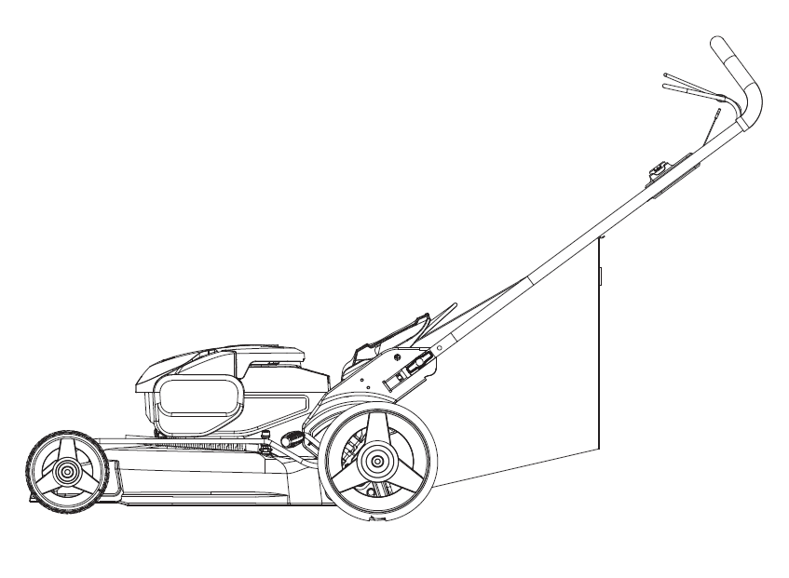

Original Instructions

Product safety

General Safety Warnings
WARNING Read all safety warnings and all instructions. Failure to follow the warnings and instructions may result in electric shock, fire and/or serious injury.
Carefully read the instructions for the safe operation of the machine.
Save all warnings and instructions for future reference.
-This appliance is not intended for use by persons (including children) with reduced physical, sensory or mental capabilities, or lack of experience and knowledge, unless they have been given supervision or instruction concerning use of the appliance by a person responsible for their safety.
-Children should be supervised to ensure that they do not play with the appliance.
- The appliance is only to be used with the power supply unit provided with the appliance.
IMPORTANT
READ CAREFULLY BEFORE USE
KEEP FOR FUTURE REFERENCE
Safe operation practices
Training
a) read the instructions carefully. Be familiar with the controls and the proper use of the equipment;
b) never allow children or people unfamiliar with these instructions to use the lawnmower. Local regulations can restrict the age of the operator;
c) never mow while people, especially children, or pets are nearby;
d) keep in mind that the operator or user is responsible for accidents or hazards
occurring to other people or their property
Preparation
- While mowing, always wear substantial footwear and long trousers. Do not operate the equipment when barefoot or wearing open sandals;
- thoroughly inspect the area where the equipment is to be used and remove all objects which can be thrown by the machine;
- Before using, always visually inspect to see that the blades, blade bolts and cutter assembly are not worn or damaged. Replace worn or damaged blades and bolts in sets to preserve balance. Replace damaged and unreadable labels.
Operation
- mow only in daylight or in good artificial light;
- avoid operating the equipment in wet grass, where feasible;
- always be sure of your footing on slopes;
- walk, never run;
- for wheeled rotary machines, mow across the face of slopes, never up and down;
mow across the face of slopes, never up and down.
- exercise extreme caution when changing direction on slopes;
- do not mow excessively steep slopes;
- use extreme caution when reversing or pulling the lawnmower towards you;
- stop the blade(s) if the lawnmower has to be tilted for transportation when crossing surfaces other than grass, and when transporting the lawnmower to and from the area to be mowed;
- never operate the lawnmower with defective guards , or without safety devices, for example deflectors and/or grass catchers, in place;
- switch on the motor carefully according to instructions and with feet well away from the blade(s);
- do not tilt the lawnmower when switching on the motor, except if the lawnmower has to be tilted for starting. In this case, do not tilt it more than absolutely necessary and lift only the part which is away from the operator;
- do not put hands or feet near or under rotating parts. Keep clear of the discharge opening at all times;
- not to touch the blades before the disabling device has been removed and the blades have come to a complete stop;
- Do not start the lawnmower when standing in front of the discharge opening.
- Do not transport the lawnmower while the power source is running.
- Stop the lawnmower,and remove the disabling device. Make sure that all moving parts have come to a complete stop.
  - whenever leaving the machine unattended,
  - before clearing a blockage,
  - before checking, cleaning or working on the machine,
  - after striking a foreign object. Inspect the machine for damage and make repairs before restarting and operating the lawnmower
If the lawnmower starts to vibrate abnormally (check immediately)
- inspect for damage.
-replace or repair any damaged parts.
-check and tighten any loose parts.
Maintenance and storage
- keep all nuts, bolts and screws tight to be sure the equipment is in safe working condition;
- check the grass catcher frequently for wear or deterioration;
- replace worn or damaged parts for safety. Use only genuine replacement parts and accessories.
- Be careful during adjusting of the lawnmower to prevent entrapment of the fingers between moving blades and fixed parts of the lawnmower.
- Always allow the lawwnmower to cool down before storing.
- When servicing the blades be aware that, even though the power source is switched off, the blades can still be moved.

Safety Warnings for battery pack
- Do not dismantle, open or shred cells or battery pack.
- Do not short-circuit a battery pack. Do not store battery packs haphazardly in a box or drawer where they may short-circuit each other or be short-circuited by conductive materials. When battery pack is not in use, keep it away from other metal objects, like paper clips, coins, keys, nails, screws or other small metal objects, that can make a connection from one terminal to another. Shorting the battery terminals together may cause burns or a fire.
- Do not expose battery pack to heat or fire. Avoid storage in direct sunlight.
- Do not subject battery pack to mechanical shock.
- In the event of battery leaking, do not allow the liquid to come into contact with the skin or eyes. If contact has been made, wash the affected area with copious amounts of water and seek medical advice.
- Seek medical advice immediately if a cell or battery pack has been swallowed.
- Keep battery pack clean and dry.
- Wipe the battery pack terminals with a clean dry cloth if they become dirty.
- Battery pack needs to be charged before use. Always refer to this instruction and use the correct charging procedure.
- Do not maintain battery pack on charge when not in use.
- After extended periods of storage, it may be necessary to charge and discharge the battery pack several times to obtain maximum performance.
- Battery pack gives its best performance when it is operated at normal room temperature (20 °C ± 5 °C).
- When disposing of battery packs, keep battery packs of different electrochemical systems separate from each other.
- Recharge only with the charger specified by WORX. Do not use any charger other than that specifically provided for use with the equipment. A charger that is suitable for one type of battery pack may create a risk of fire when used with another battery pack.
- Do not use any battery pack which is not designed for use with the equipment.
- Keep battery pack out of the reach of children.
- Retain the original product literature for future reference.
- Remove the battery from the equipment when not in use.
- Dispose of properly.
- Do not mix cells of different manufacture, capacity, size or type within a device.
- Do not remove battery pack from its original packaging until required for use.
- Observe the plus (+) and minus (–) marks on the battery and ensure correct use.

SYMBOLS
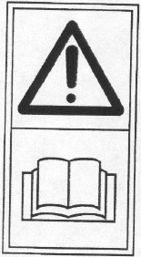
Read instruction handbook before operation this machine

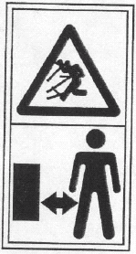
Keep bystanders away.

Beware of sharp blades. Blades continue to rotate after the motor is switched off- Remove disabling device before maintenance

 Do not expose to rain or water
 Do not burn
 Do not dispose of batteries. Return exhausted batteries to your local collection or recycling point.
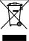
Waste electrical products should not be disposed of with household waste. Please recycle where facilities exist. Check with your Local Authority or retailer for recycling advice.
Wear protective gloves.

 Remove battery from the socket before carrying out any adjustment, servicing or maintenance.
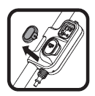 Remove the key

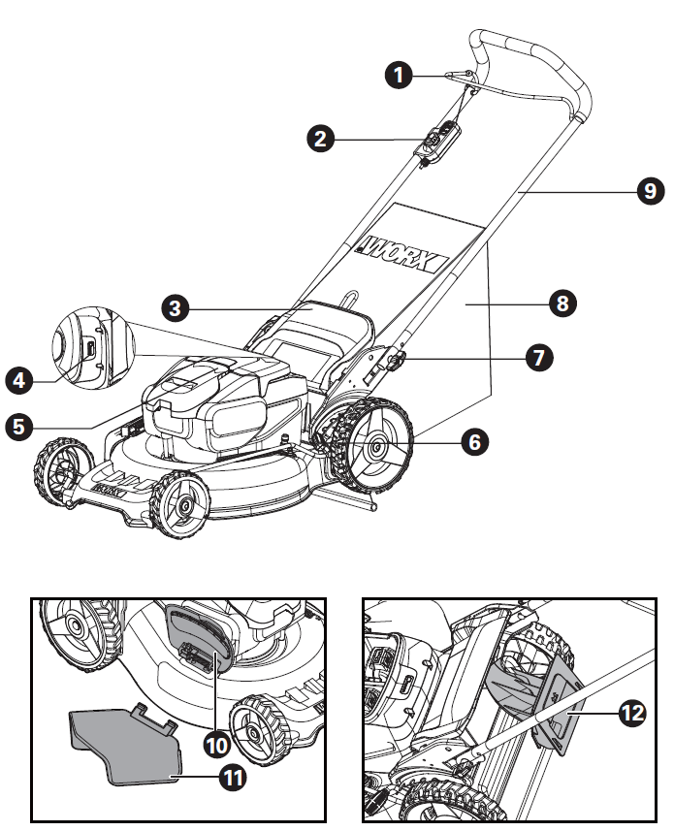
10
根据欧款机器更新图片，注意部件6附近的位置与美款是有区别的。
COMPONENT LIST
3
4
5
7
8
    - Operating Bail
    - Safety Key
    - Safety Flap
    - Power indicator light
    - Battery pack cover
    - Cutting height adjustment lever
    - Handle knob
    - Grass collection bag
    - Handle Bar
    - Side-discharge cover
    - Side-discharge chute
- Mulching insert
- Battery pack* (See Fig. F2)
- Blade bolt (see Fig. N1)
- Blade (see Fig. N1)
- Spacer (see Fig. N1)

*Not all the accessories illustrated or described are included in standard delivery.

TECHNICAL DATA
Type WG751E WG751E.9 (770-789- designation of machinery, representative of Cordless Lawn Mower)

 | WG751E | WG751E.9
Voltage | 40VMax.(2x20V Max.)**
No load speed | 2700 /min
Deck diameter | 51 cm
Cutting diameter | 48 cm
Front wheel diameter | 180 mm
Rear wheel diameter | 250 mm
Cutting height | 20 – 80 mm
Cutting height positions | 7
Grass collection capacity | 50 L
Battery capacity | 4.0 Ah (WA3553) | /
Battery type | Lithium-Ion | /
Charger Model | WA3883 | /
Charger rating | Input: AC 100-240V~50/60Hz  Output 1: 20 V, 2.0 A***  Output 2: 20 V, 2.0 A*** | /
Charging time (approx.)  4.0 Ah (1 pc)  4.0 Ah (2 pcs) | 2 hrs  4 hrs | /
Machine Weight | 24.3 kg | 23 kg

**Voltage measured without workload. Initial battery voltage reaches maximum of 20 volts. Nominal voltage is 18 volts.
** *Charger output 1 and output 2 mean two ports with the same output voltage and current.

ACCESSORIES

 | WG751E | WG751E.9
Battery pack (WA3553) | 2 | /
Charger (WA3883) | 1 | /
Grass collection bag | 1
Mulching insert | 1
Side-discharge chute | 1
We recommend that you purchase your accessories from the same store that sold you the tool. Choose the type according to the work you intend to undertake. Refer to the accessory packaging for further details. Store personnel can assist you and offer advice.

Noise Data
A weighted sound pressure L_{pA} : 64.0 dB (A)
K_{PA =}3.0 dB (A)
A weighted sound power L_{w}A: 84.0 dB (A)
K_{wA =}3.0 dB (A)

Wear ear protection.

Vibration information
Typical weighted vibration a_{h} = 0.494 m/s² , uncertainty K = 1.5 m/s²
WARNING: The vibration emission value during actual use of the power tool can differ from the declared value depending on the ways in which the tool is used dependant on the following examples and other variations on how the tool is used:
How the tool is used and the materials being cut or drilled.
The tool being in good condition and well maintained.
Using the correct accessory for the tool and ensuring it is sharp and in good condition.
The tightness of the grip on the handles and if any anti vibration accessories are used.
And the tool is being used as intended by its design and these instructions.
This tool may cause hand-arm vibration syndrome if its use is not adequately managed
WARNING: To be accurate, an estimation of exposure level in the actual conditions of use should also take account of all parts of the operating cycle such as the times when the tool is switched off and when it is running idle but not actually doing the job. This may significantly reduce the exposure level over the total working period.

Helping to minimise your vibration exposure risk.
ALWAYS use sharp chisels, drills and blades.
Maintain this tool in accordance with these instructions and keep well lubricated (where appropriate).
If the tool is to be used regularly then invest in anti vibration accessories.
Avoid using tools in temperatures of 10⁰C or less.
Plan your work schedule to spread any high vibration tool use across a number of days.

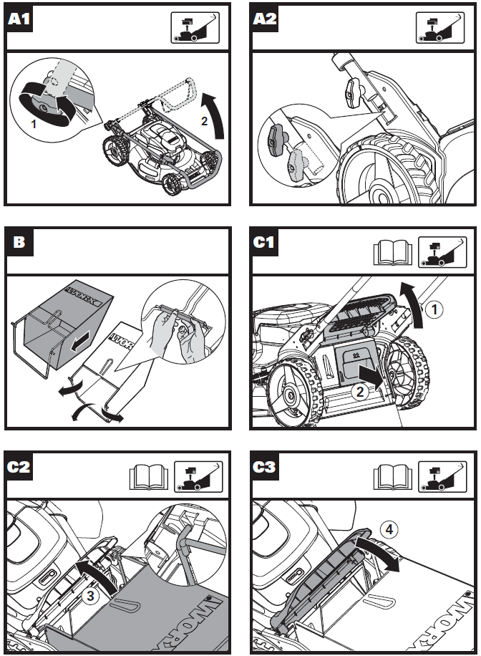

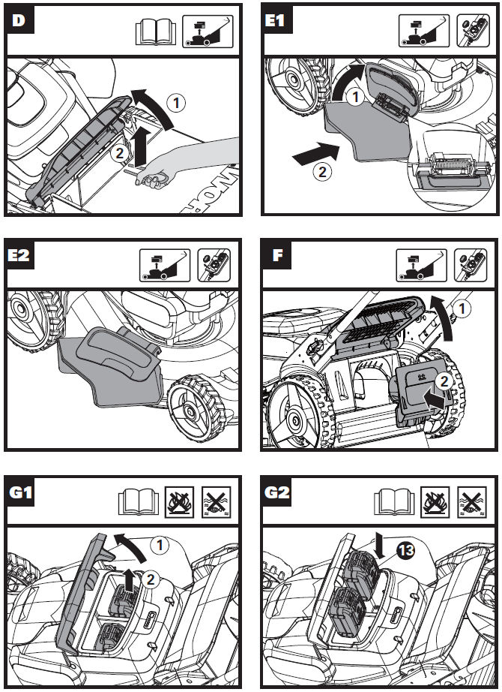
E
F1
F2
11
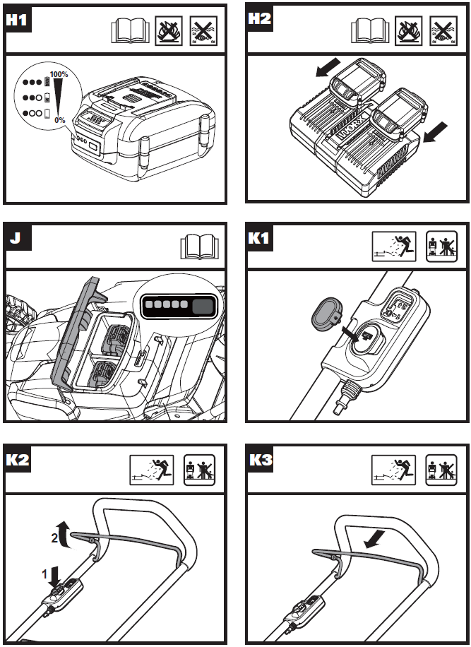
G1
I3
I2
I1
H
G2
电池包WA3553，充电器WA3883，请更新相关的图片。
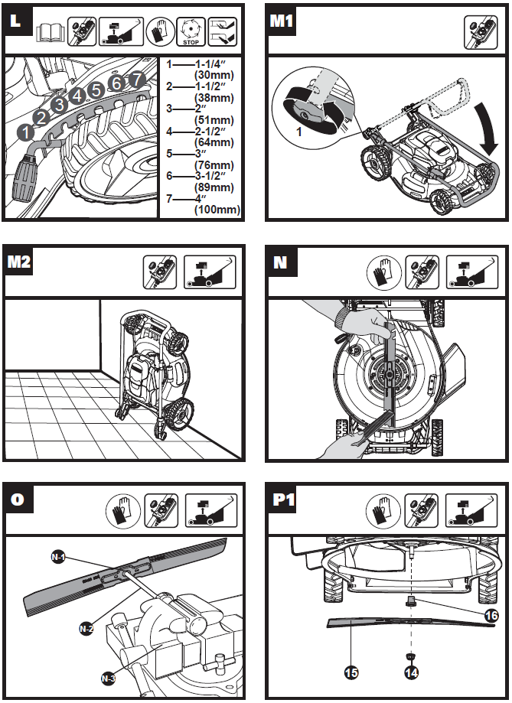
图O里的N-1，N-2，N-3换成M-1，M-2，M-3
J
K1
N1
K2
L
M
14
13
12
1 — 20mm
2 — 30mm
3 — 40mm
4 — 50mm
5 — 60mm
6 — 70mm
7 — 80mm
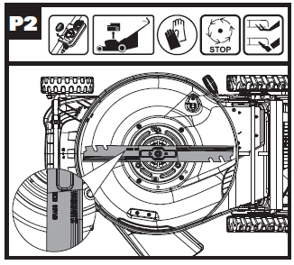
N2

OPERATION INSTRUCTION


NOTE: Read instruction handbook before operation this machine.

ASSEMBLY & OPERATION

ACTION | FIGURE
ASSEMBLY
Assembling the handle bar | See Fig. A1
Adjustment of Handle’s height | See Fig. A2
Assembling the grass collection bag | See Fig. B
Assembling the grass collection bag to the lawn mower  NOTE: Depress the grass collection bag slightly to ensure that it is completely installed.  NOTE: Take the mulching insert out of the lawn mower before fitting the grass collection bag. | See Fig. C1, C2, C3
Removing/emptying grass collection bag    WARNING! Always check the safety flap close the discharge outlet before using. Never lift the safety flap when the lawn mower is being used without fitted grass collection bag. | See Fig. D
Installing side-discharge chute | See Fig. E1 E2
Installing mulching insert | See Fig. E
Removing /fitting the battery pack  NOTE: This machine will only run when 2 batteries are installed. It is recommended to use the same two batteries and charge the two batteries at the same time.  When you use two batteries with different power, the machine will only run to the lower common denominator. | See Fig. F1, F2
Checking the battery charge condition  NOTE: Fig. G1 only applies for the battery pack with battery indicator light. | See Fig. G1
Charging the battery pack  NOTE: The batteries are shipped uncharged. Each battery must be fully charged before the first mow.  Always fully charge the two batteries at same time. More details can be found in charger’s manual. | See Fig. G2
OPERATION
Power indicator light  See details in BATTERY STATUS part  IMPORTANT:  When only one light is illuminated, your battery is overly discharged, even though the machine may still be capable to work. Continuing to operate your machine with the battery in this discharged condition may reduce the life and performance of your battery.  When no light is illuminated, at least one battery is not fully installed or battery may be defective, please double check the batteries are fully seated into position. | See Fig. H
Starting and Stopping | See Fig. I1, I2, I3
Adjusting the cutting height  WARNING! Stop, release switch lever and wait until the motor stops before adjusting height. The blades continue to rotate after the machine is switched off, a rotating blade can cause injury. Do not touch rotating blades. | See Fig. J
Storage | See Fig. K1, K2

BATTERY STATUS (See Fig. H)
- Before starting or after use, press the button beside the power indicator light on the machine to check the battery capacity.
- During operation, the battery capacity will be indicated automatically by the battery power indicator. The indicator constantly senses and displays the battery condition as follows.
- For the machine with 2 battery packs with different power, the power indicator light displays the battery condition with the lower one of the two batteries.

Battery indicator light status | Battery condition
Five green lights () are illuminated. | The two batteries are in a highly charged condition.
Two, three or four green lights are illuminated. | The two batteries have a remaining charge. The more lights are illuminated, the more battery capacity.
Only one green light () is illuminated. | The battery level of at least one battery pack is very low. Please check and charge the battery pack.
No light is illuminated. | At least one battery is not fully installed or battery may be defective.
Only one light is flashing twice per cycle. | At least one battery is over discharged (please refer to the battery charge condition), please recharge the two batteries at once before use again or storage.
Only one light is flashing three times per cycle. | At least one battery is hot, wait for them cool down before start again.
Only one light is flashing four times per cycle. | The machine is over load. Raise the cutting height or push slowly.

MULCHING MOWING TIPS
While mulching, your new mower is designed to cut the grass clippings into small pieces and distribute them back into the lawn. Under normal conditions, the mulched grass will biodegrade quickly and deliver nutrients to the lawn. Please review the following recommendations for optimum mulching performance.
- Avoid mowing when the grass is wet from rain or dew. Wet grass may form clumps which interfere with the mulching action and reduce the runtime. The best time to mow the grass is in the late afternoon when the grass is dry and the newly cut area will not be exposed to direct sunlight.
- For the best mulching performance, set the cutting height to remove about one third of the grass blade length, ideally no more than 40mm at one time. If the lawn is overgrown, it may be necessary to increase the cutting height to reduce the pushing effort and prevent overloading the motor. For extremely heavy mulching, it is advisable to first cut at a high cut height setting, and then re-cut to the final cut height. Otherwise, make narrower cuts and mow slowly.
- For the best performance, keep the mower housing free of built-up grass. From time to time turn off mower and wait for the blades to come to a complete stop. Then unplug the safety key and turn mower on its side. Using an object such as a stick, wipe out any accumulation of grass around the blade area. Be careful of the sharp edges of the blade. Ensure to clean the blade area often when cutting wet or new grass and every time after the machine is used.
- Certain types of grass or grass conditions may require that an area be mulched a second time to fully disperse the grass throughout the lawn. If cutting a second time, it is advisable to cut perpendicular (across) the first cut pattern. DO NOT CHANGE CUT PATTERN IN ANY WAY THAT WOULD CAUSE MOWING DOWN A HILL.
- Change your cutting pattern from week to week. This will help prevent matting and graining of the lawn.

CUTTING AREA
The cutting area can be affected by several factors, such as cutting height, lawn humidity, grass length and density. Besides, starting and stopping the mower too many times during operation will reduce the cutting area.
The table below gives the relationship between cutting conditions and cutting area.

Cutting Height | Cutting Area (maximum)
Cut 8cm to 6cm | 460m² *

* Used with two fully charged battery packs.

TIPS:
- It is recommended to mow your lawn more frequently, walk at normal pace, and not to start/stop the mower too often during operation.
- For best performance, please ensure use two fully charged battery packs at the same time and always cut off 1/3 or less of the grass height.
- Walk slowly when cutting long grass, so as to have more effective cutting and properly discharge the clippings.
- Avoid cutting wet grass, otherwise it will stick to the underside of the deck and the clippings cannot be collected or discharged properly.
- A higher cutting height shall be applied to new or thick grass and it will extend the battery duration.

MAINTENANCE

WARNING: Stop the mower and remove the safety key before removing the grass collection bag.
Note: To ensure long and reliable service, perform the following maintenance procedures regularly. Check for obvious defects such as a loose, dislodged or a damaged blade, loose fittings, and worn or damaged components. Check that the covers and guards are all undamaged and are correctly attached to mower. Carry out any necessary maintenance or repairs before operating mower. If the mower should happen to fail despite regular maintenance, please call our customer helpline for advice.

BLADE SHARPENING
KEEP BLADE SHARP FOR BEST MOWER PERFORMANCE. A DULL BLADE DOES NOT CUT GRASS CLEANLY OR MULCH PROPERLY.
WEAR PROPER EYE PROTECTION WHILE REMOVING, SHARPENING, AND INSTALLING BLADE. ENSURE THAT SAFETY KEY IS REMOVED.
Sharpening the blade twice during a mowing season is usually sufficient under normal circumstances. Sand causes the blade to dull quickly. If your lawn has sandy soil, more frequent sharpening may be required.
REPLACE BENT OR DAMAGED BLADE IMMEDIATELY.

WHEN SHARPENING THE BLADE (See Fig. L)
1. Make sure blade remains balanced.
2. Sharpen blade at the original cutting angle.
3. Sharpen cutting edges on both ends of blade to keep it balanced, removing equal amounts of material from both ends.
Note:
1. Be sure the mower is turned off and remove the key.
2. Place the mower in stand up storage mode.

BLADE BALANCING (See Fig. M)
Check balance of blade by placing center hole in blade M-1 over a nail or screwdriver shank M-2, clamped horizontally in a vise M-3. If either end of the blade rotates downward, file that end. Blade is properly balanced when neither end drops.

BLADE MAINTENANCE (See Fig. N1, N2)
Replace your metal Blade after 50 hours mowing or 2 years, which ever is the sooner-regardless of condition.
Follow these procedures to remove and replace the Blade. You will need garden gloves (not provided) and a spanner wrench (not provided) to remove the Blade. Hold the Blade and unscrew the Blade Bolt counter-clockwise using a spanner wrench, and then remove the Blade.
To re-assemble, position the Blade with the cutting edges towards the ground. Then securely tighten the Blade Bolt.

STORAGE (See Fig. K1,K 2)
Stop the mower and always remove the Safety Key. Clean the exterior of the machine thoroughly using a soft brush and cloth. Do not use water, solvents or polishes. Remove all grass and debris, especially from the ventilation slots.
Turn the machine on its side and clean the blade area. If grass cuttings are compacted in the blade area, remove with a wooden or plastic implement.
Store the machine in a dry place. Do not place other objects on top of the machine.
To aid storage, release the Handle knobs, and rotate or fold the Upper Handle.

TROUBLE SHOOTING

PROBLEM | SOLUTION
1. Mower doesn’t run when switch lever is activated. | A. Check to make sure safety key has been installed and is fully seated and that button on switch housing is being completely pushed.  B. Release switch lever to turn mower off. Remove safety key, turn mower over and check that blade is free to turn. If not free, return to an authorized servicer. Blade should turn freely.  C. Has battery been fully charged? Plug in charger and wait for green light to come on.
2. Motor stops while mowing. | A. Release switch lever to turn mower off. Remove safety key, turn mower over and check that blade is free to turn. If not free, return to an authorized servicer. Blade should turn freely.  B. Raise cutting height of wheels to highest position and start mower.  C. Has battery been fully charged? Plug in charger and wait for green light to come on.  D. Avoid overloading the mower. Slow down the cutting pace by pushing mower slower or raise the cut height. Or both.
3. Mower runs but cutting performance is unsatisfactory, or does not cut entire lawn. | A. Has battery been fully charged? Plug in charger and wait for green light to come on.”  B. Release switch lever to turn mower off. Remove safety key. Turn mower over and check: Blade for sharpness - Keep blade sharp. Deck and discharge chute for clogging.  C. Wheel height adjustment may be set too low for grass condition. Raise cutting height.
4. Mower is too hard to push. | A. Raise cutting height to reduce deck drag on grass. Check each wheel for free rotation.
5. Mower is abnormally noisy and vibrates. | A. Release switch lever to turn mower off. Remove safety key. Turn mower on side and check blade to ensure it has not been bent or damaged. If blade is damaged, replace with a replacement blade. If the underside of the deck is damaged return mower to an Authorized service center.  B. If there is no visible damage to the blade and the mower still vibrates: Release switch lever to turn mower off, remove safety key and remove blade. Rotate blade 180 degrees and retighten. If mower still vibrates, return the mower to an authorized service center.
6. Battery charger LED’s not on. | A. Check plug connection.  B. Replace charger.
7. Battery charger LED does not flip to green. | A. Battery needs to be diagnosed. Take to authorized service center.
8. Mower not picking up clippings with the Grass Collection Bag. | A. Remove mulch plate when bagging.  B. Chute clogged. Release switch lever to turn mower off. Remove safety key. Clear chute of grass clippings.  C. Too much cut grass. Raise cutting height of wheels to shorten length of the cut.  D. Bag full. Empty bag more often.
9. When mulching there are clippings visible. | A. Too much cut grass. Raise cutting height of wheels to shorten length of the cut. Do not cut off more than 1/3 of total length.  B. Check blade for sharpness. Always keep blade sharp.
10. Low or diminished run-time after many uses | A. Return to Authorized Service location - may need new battery.
11. The battery charger LED flashes red and the battery can’t be charged. | A. The battery overheats after continuous use. Remove battery from the charger and allow it to cool to 42℃ or less.

FOR BATTERY TOOLS
The ambient temperature range for the use and storage of tool and battery is 0℃-45℃ (32℉-113℉).
The recommended ambient temperature range for the charging system during charging is 0℃-40℃ (32℉-104℉).

ENVIRONMENTAL PROTECTION
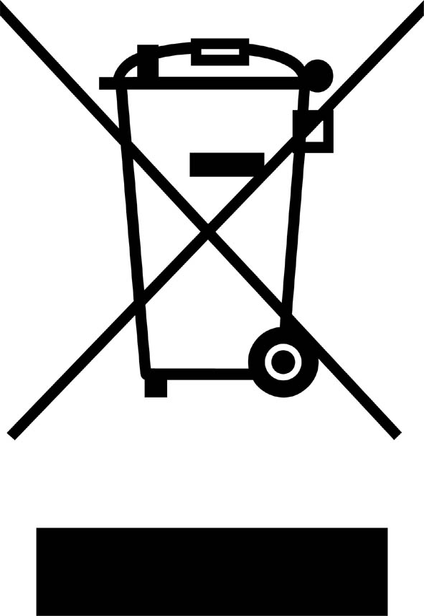
Waste electrical products must not be disposed of with household waste. Please recycle where facilities exist. Check with your local authorities or retailer for recycling advice.

DECLARATION OF CONFORMITY

We,
Positec Germany GmbH
Grüner Weg 10, 50825 Cologne, Germany
Declare that the product
Description WORX Cordless Lawn Mower
Type WG751E WG751E.9 (770-789- designation of machinery, representative of Cordless Lawn Mower)
Function mowing grass

Complies with the following Directives,
2006/42/EC, 2014/30/EU, 2011/65/EU, 2000/14/EC amended by 2005/88/EC

2000/14/EC amended by 2005/88/EC
Conformity assessment procedure as per Annex VI
Measured Sound Power Level 84 dB(A)
Declared Guaranteed Sound Power Level 87 dB(A)

The notified body involved
Name: Intertek Testing & Certification Ltd (notified body 0359)
Address: Davy Avenue, Knowlhill, Milton Keynes, MK5 8NL

Standards conform to,
EN 60335-1, EN 60335-2-77, EN 62233, EN ISO 3744, EN 55014-1, EN 55014-2

The person authorized to compile the technical file,
Name Marcel Filz
Address Positec Germany GmbH, Grüner Weg 10, 50825 Cologne, Germany

Signature:

2017/xx/xx
Allen Ding
Deputy Chief Engineer, Testing & Certification
Positec Technology (China) Co., Ltd
18, Dongwang Road, Suzhou Industrial
Park, Jiangsu 215123, P. R. China


